**CSE530: EOSI - ASSIGNMENT 3 SETUP INSTRUCTIONS**

**Part 2**

**ACCURATE DELAYS IN LINUX (WS2812)**

**Files Included:**

1. timer_delay_test.c (This is timing measurement experimentation code)

2. ws2812.c (This is a char driver to interface with WS2812)

3. main.c (This is the user level program to test implementation of ndelays. This is same as Part 1)

4. Makefile

Please refer the Report for Implementation details and Experimentation Results.

**Steps to Setup**

**1. Connect the LED Strip to its respective pins as mentioned below:**

IO1 (GPIO12) → DI

5V → 5V

GND → GND

**2. Update the makefile as per the following instructions**

**GALILEO_USER → Enter the user name. Default “root”**

**GALILEO_IP → Enter Galileo IO. Default “192.168.1.5”**

**IOT_HOME → Enter sysroots address**

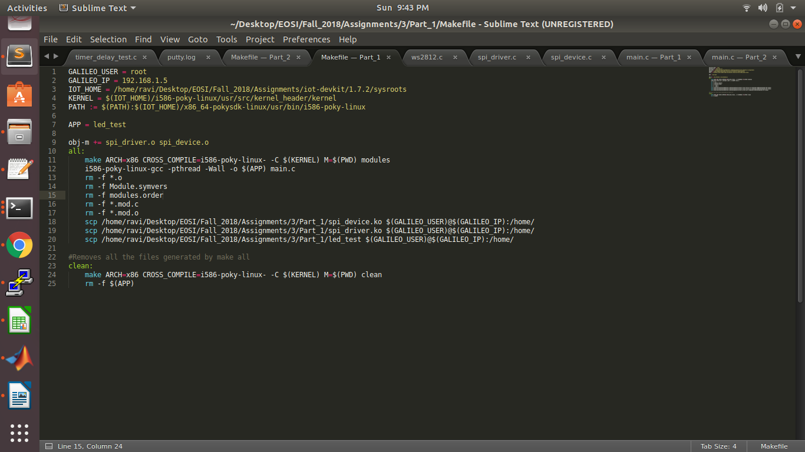

**3. Insert the modules loaded on the /home directory onto kernel using the following commands in any order. Please see the image for the expected output**

First inorder to run the measurement tests

cd /home

insmod timer_delay_test.ko

This would print measurement outputs of the timing experiments which involves ndelay and hrtimers.

**In order to test the driver implementation using the ndelay that uses the bit-banging approach do the following steps. Please note that we will need to remove the earlier inserted module here.**

rmmod timer_delay_test.ko

insmod ws2812.ko

**4. User Level Test Code: Run the ./led_test command from /home directory. This would ask you to input the following entries:**

- No of LEDs to switch on currently

- No of times you want the pattern to run in circles

- Led color for each led that you want to light up

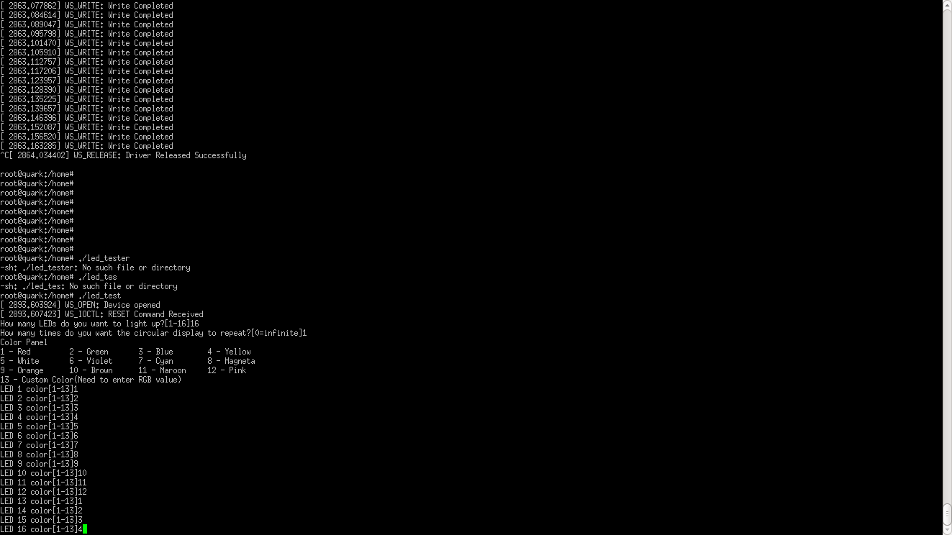

As can be seen in the image above, we were asked for the choices as explained earlier.

Upon successful user input, it successfully calls WS_WRITE function from the driver file_operations datastructures. This is evident by the printing as shown below.

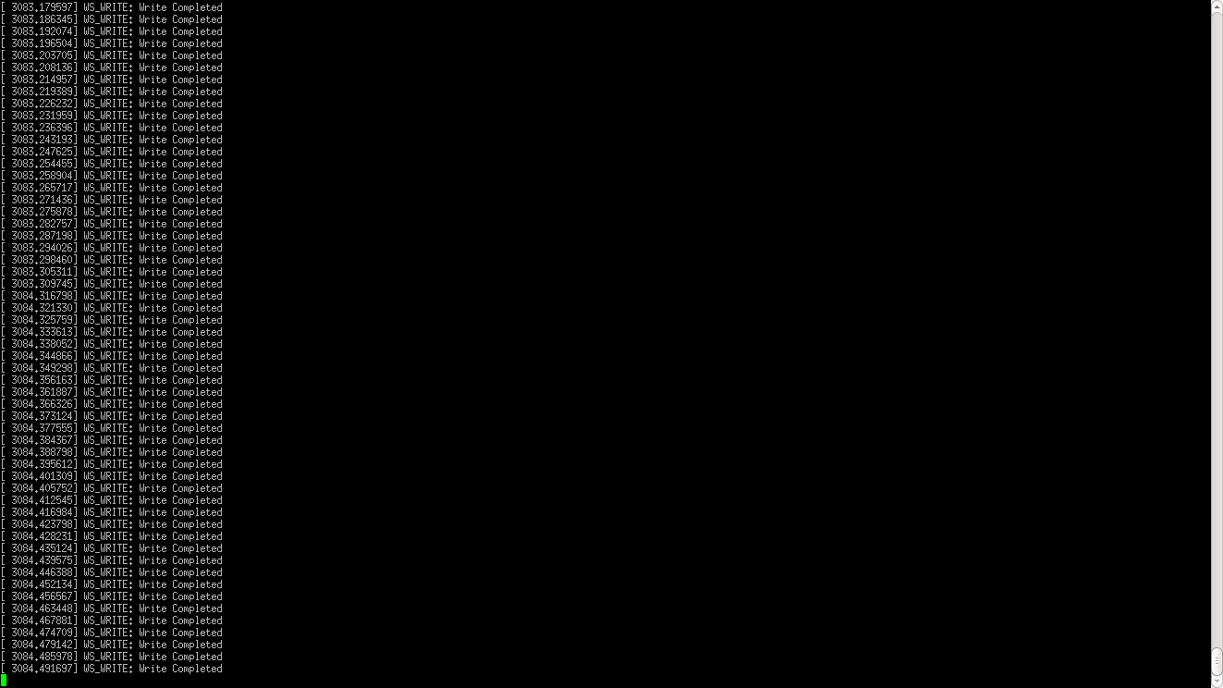

The LED Ring looks as follows for the color inputs chosen by me.

